Zhen Peng

Try to be a good teacher
When I was a child, I am always asked what you want to be in the future. To be honest, I have never been thinking of being a teacher, especially to be an English teacher. I am used to dream to be an official lady or a doctor. Now, I am a student of Adelphi University and my major is TESOL (Teaching English to Speakers of Other Languages). I was bad at English when I was in the high school and I used to be the last one of the class. It is so funny that I will be an English teacher in the future. Anyway, I will be an English teacher in the future.
I still remember why I didn’t want to be a teacher. Because when I was in my elementary school, all my teachers were strict with us and they were not patient. After I read Gottlieb, M. (2006) Assessing English Language Learners. Bridges from Language Proficiency to Academic Achievement to Educational Equity. Thousand Oaks, CA: Corwin Press. Chapter 1, I learned a lot and I do think that assessment of the subject which you teach are very important that you can not only improve yourself but also help your students.
As we all know, to be a good teacher especially to be a favorite teacher is not easy. Gottlieb, M (2006) claimed that as educators, we are constantly challenged to make informed decisions about our students; to do so, we plan, gather, and analyze information from multiple sources over time so that the results are meaningful to teaching and learning. That’s the core of the assessment process and the centerpiece in the education of linguistically and culturally diverse students. If reliable, valid, and fair for our students, assessment can be the bridge to educational equity. I do agree a good teacher and a teacher who has responsibilities have to do your lesson plan well and have to do assessment after class. After I finished the article, I know that good assessments are really helpful. Meanwhile, I learned that the ways how you teach, the measures, the standard tests and the environment can influence classes.
Look at the chat as follows:
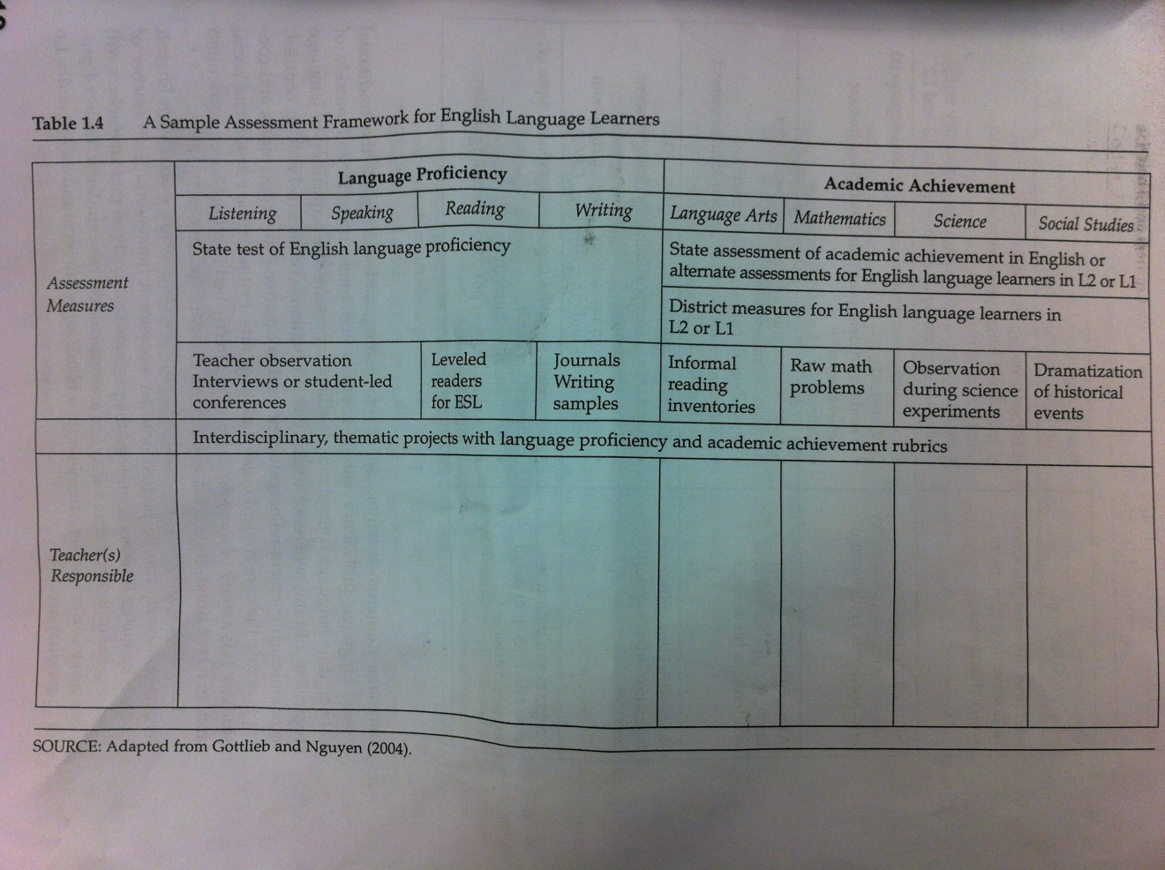
It is a sample assessment framework for English language. I do agree this kind of material to get your assessment and improve yourself. It reminded me that when I was learning English of my high school, I didn’t think my teacher has this framework to assess our study. They just followed their lesson plans. Therefore, they would just follow the rubric which was given by the institute. I still remembered that I misunderstood the question of my midterm in my high school and my teacher just gave me 2 points of 30. The 2 points just gave for my handwriting. She just followed the rubric but she didn’t give me a second chance to do it again and she mentioned that someone made unaccepted mistake in class. She just thought that I didn’t understand and I got the lowest marks. I was really suffered a hard time because of the lowest marks and my classmates looked down upon me.
This is another chat for an assessment system for English Language Leaners.
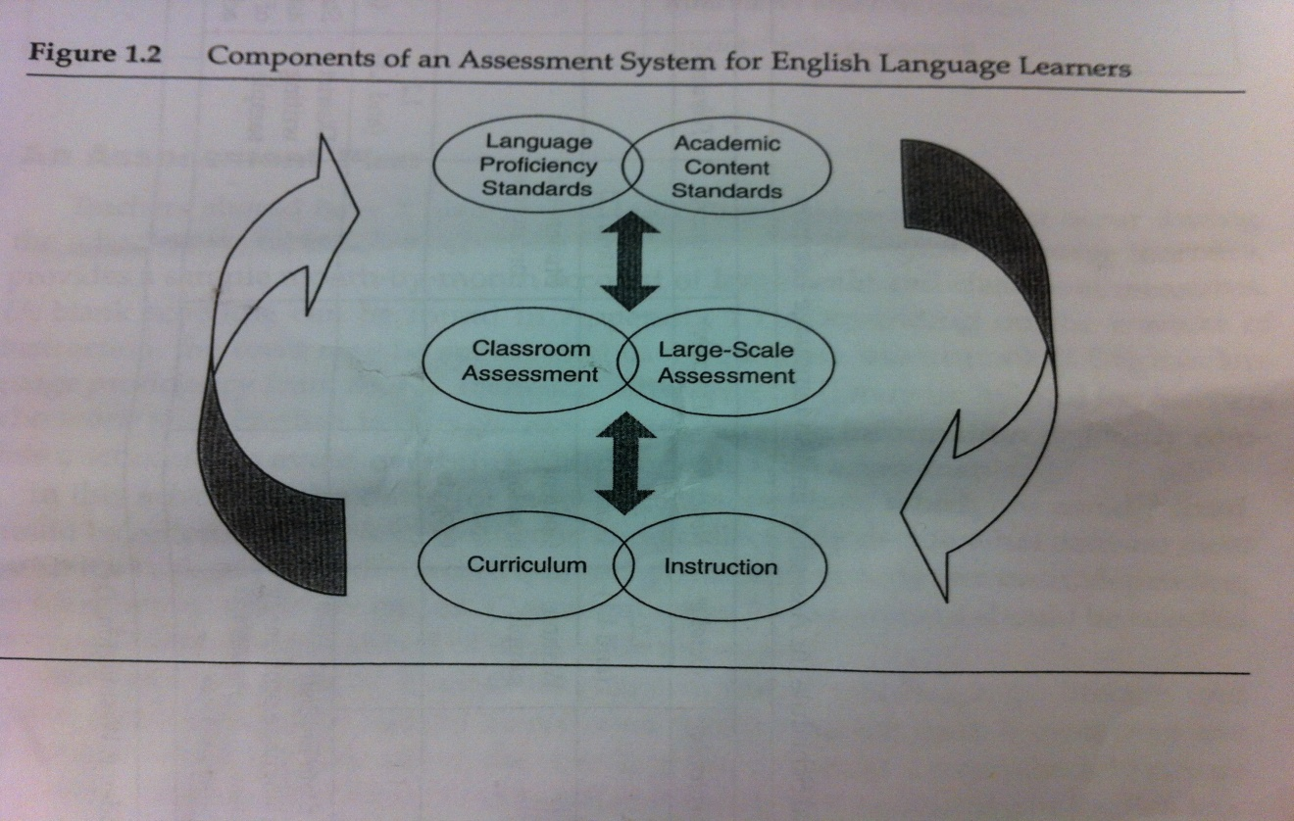

It is a good chat to analyze the factors of assessment system influence each other and relatively complemented. It tells us the assessment is not only some particular factors but also every factor influence each other.
In conclusion, try to be a good teacher is not easy but it is a really skillful thing. Therefore, it pushes the teacher to learn more, read more and practice more.

Reference
Gottlieb, M. (2006) Assessing English Language Learners. Bridges from Language Proficiency to Academic Achievement to Educational Equity. Thousand Oaks, CA: Corwin Press. Chapter 1

